**A.P. Literature and Composition**

**Summer Reading 2024-2025**

**Welcome to AP Literature!**

AP English Literature and Composition is equivalent to an introductory college-level literary analysis course. As such, you must be willing to read the assigned novels and plays. In this course, you can expect to read, discuss, and analyze fictional works, as well as improve your writing skills.

**Why Summer Reading**? At the end the school year, you will take the AP English Literature and Composition exam. We will read several books/plays over the course of the school year. This summer, you will read and annotate two titles that we will study the first quarter. This will lessen your reading load as you begin the school year, and will allow more time for analysis/activities. It is recommended that you purchase your own personal copy of each book so you can write/annotate directly in the book. Library books are acceptable, however you will need to annote using sticky notes.

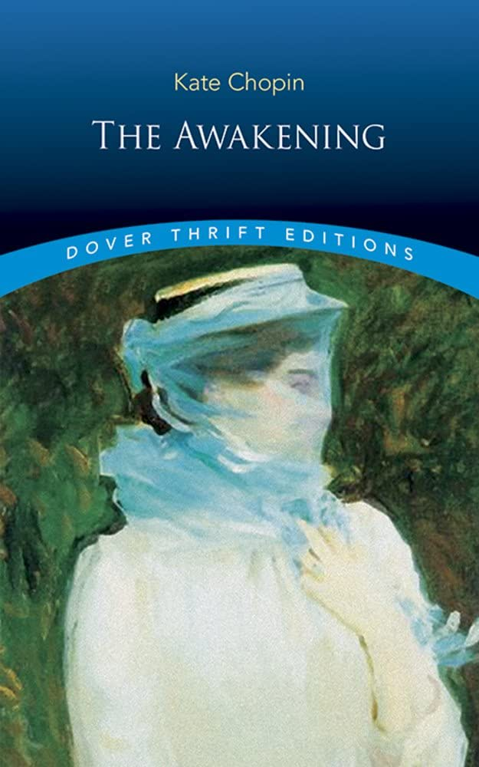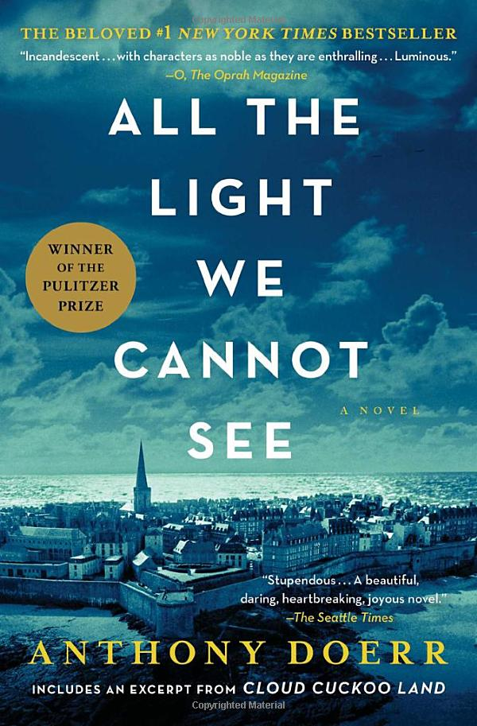

**Books:**

*The Awakening* by Kate Chopin

*All the Light We Cannot See* by Anthony Doerr

**Assignments:**

* ***The Awakening* by Kate Chopin**

1. **Test: there will be a test on this book during the second week of school.**
2. **Assignment: Handwritten Dialectical Journal (20 entries) – due first day of school (see below)**

* ***All the Light We Cannot See* by Anthony Doerr**

1. **Test: There will be a test on this book during the first quarter.**
2. **Assignment: Read/annotate your book. Annotating** consists of both **marking passages** in the book and **writing comments**. You can do this in a variety of ways including using sticky notes, color coding with highlighters, or underlining/circling. Please have your annotations **available for teacher review** **on the first day of school.** Additionally, you will be tested on this novel so you should take notes in a way that allows you to review for your test when the time comes.

**Dialectical Journal (For *The Awakening*)**

*The Awakening*: **Dialectical Journal (handwritten neatly in ink): submit on the first day of school)**

The term “dialectic” means “the art or practice of arriving at the truth by using conversation involving question and answer.” The process is meant to help you develop a better understanding of the text.

**Dialectical Journal Directions:** As you read *The Awakening*, **annotate**, or use sticky notes to note *important/pivotal passages and quotes*. Then, review your annotations and **choose 20 passages**/quotes that stand out to you and record them in the left-hand column of a chart, including chapter and page numbers (should cover the entirety of the book). Identify the type of entry in the middle column. In the right column, analyze the function of the passage in the context of the novel (in several sentences).

For the annotations (left-hand) column, your entries should include a variety of the following (try to use each element at least once):

1. **Plot:** a pivotal event that supports a theme) or structural shifts or turns in the plot
2. **Characterization**: showing how a character is developed/changed
3. **Setting:** showing the significance of setting to the theme
4. **Patterns:** recurring images, ideas, colors, symbols or motifs
5. **Irony**: (Verbal, Dramatic, or Situational)
6. **Tone:** identify tone in commentary using a tone adjective
7. **Theme:** include a one-sentence thematic statement in your commentary
8. **Figurative language** such as metaphors, similes, personification, etc; effective &/or creative use of stylistic or literary devices
9. **Meaningful or striking quotations** or **events** you find surprising or confusing
10. Passages that **remind you of your own life** or something you’ve heard about it in our **society**
11. Passages with **confusing language or unfamiliar vocabulary**

In the middle column, identify which of the 11 elements you are noting (be specific).

For the response (right-hand) column, you have several ways to respond to a text:

* Raise questions about the beliefs and values implied in the text
* Give your personal reactions to the passage
* Discuss the diction (vocabulary) used
* Discuss what makes the quote or passage meaningful, striking, or important
* Discuss how theme is shown (through setting, dialogue, narration, plot, character)
* Discuss the meaning and/or effect of figurative language
* Discuss how the passage contributes to characterization

Dialectical Journal Example: from *Wuthering Heights* by Emily Brontë

|  |  |  |
| --- | --- | --- |
| Annotations (with chapter and page #) | Type of entry | Commentary |
| “Cathy, this lamb of yours threatens like a bull!‟ he said. It is in danger of splitting its skull against my knuckles. By God! Mr. Linton, I’m mortally sorry that you are not worth knocking down!” (11;  114). | 2. Characterization  (Indirect characterization of Heathcliff) | Heathcliff is showing his complete disdain and disrespect for Edgar. Even though Cathy has married Edgar, Heathcliff still asserts himself as a rival for her affections. He addresses Cathy first, as if Edgar were not there. The use of the animal metaphor exudes utter contempt for Edgar, as if he were a dumb animal. By using “lamb,” Bronte makes it apparent to the reader that Heathcliff considers Edgar somewhat weak. |

**\*Please be aware that students will be held responsible for the assignments on the first day of the fall semester. If a student chooses to change the level of course or class or program over the summer, the student will be held responsible for the summer assignments for the courses reflected on the schedule for the first day of school. If you have questions regarding which course you are enrolled in for the fall, please contact your guidance counselor. If you have questions regarding the above assignment, please reach out to our ELA department head at** [**weavera@pcsb.org**](mailto:weavera@pcsb.org)**.**

Have a wonderful summer!